Milestone 1 (M1)
Functionalities to be implemented as part of Milestone 1 are:
- Create ABHA number using Aadhaar / Driving License.
- Verify ABHA Number / ABHA address during patient registration.

M1 Test Cases mapping by Role
Applicable To | Private Application | Government Application
Creation of ABHA Number
Using Aadhaar OTP | Mandatory | Mandatory
Using Aadhaar Biometrics | Optional | Mandatory
Using Aadhaar Demographics (Offline) | NA | Mandatory
Using Driving License | Optional | Optional
Create ABHA Address | Mandatory | Mandatory
Download ABHA Card | Mandatory | Mandatory
Profile Update | Optional | Optional
Verification of ABHA Address
Scan Health Facility QR | Mandatory | Mandatory
Scan User ABHA QR | Optional | Optional
By OTP | Mandatory | Mandatory
New vs Returning Patients | Mandatory | Mandatory

This section covers:
- Creation of ABHA number
  - Using Aadhaar OTP
  - Create ABHA Address
  - Using Aadhaar Biometric
  - Using Aadhaar Demographics (offline)
  - Using Driving License
  - Download ABHA Card
  - Profile Update

- Verification of ABHA Number / ABHA address
  - Using ABHA Number
  - Using ABHA Address
  - Using Mobile
  - Using Aadhaar Number
  - New vs Returning Patients

Creation of ABHA Number
ABHA number is a 14 digit number that is unique (only one per person) issued only after a strong KYC. ABHA number is a core building block of the ABDM ecosystem that is designed to ensure that people can have a unique ID (identifier) for healthcare.
ABHA numbers are extremely important for helping those who use feature phones or do not use a phone to manage their personal health records. ABHA numbers are issued in assisted mode extensively by all Government health programs.
The government program/scheme, healthcare providers are encouraged to issue ABHA numbers to patients who don't carry phones and link records to the ABHA address (<14DigitABHAno>@abdm).
This section covers:
- Using Aadhaar OTP
- Using Aadhaar biometric
- Using Aadhaar demographic(offline mode)
- Using driving license
- Download ABHA Card
- Default ABHA Address
- Profile Update

Verification of ABHA Number/ ABHA Address
What is ABHA Address?
ABHA Address is an account on a HIE-CM that enables an user to get this health records linked and share these linked records with consent.
Users can create an ABHA address via a PHR application, the NHA HIE-CM Website or by creating a ABHA Number which provides a default ABHA address (14DigitABHANo@abdm). An ABHA address looks like ‘name@abdm’ (production) or ’name@sbx’ (Sandbox).
Users looking to collect their health records digtally are expected to share their ABHA address when they visit a healthcare facility.

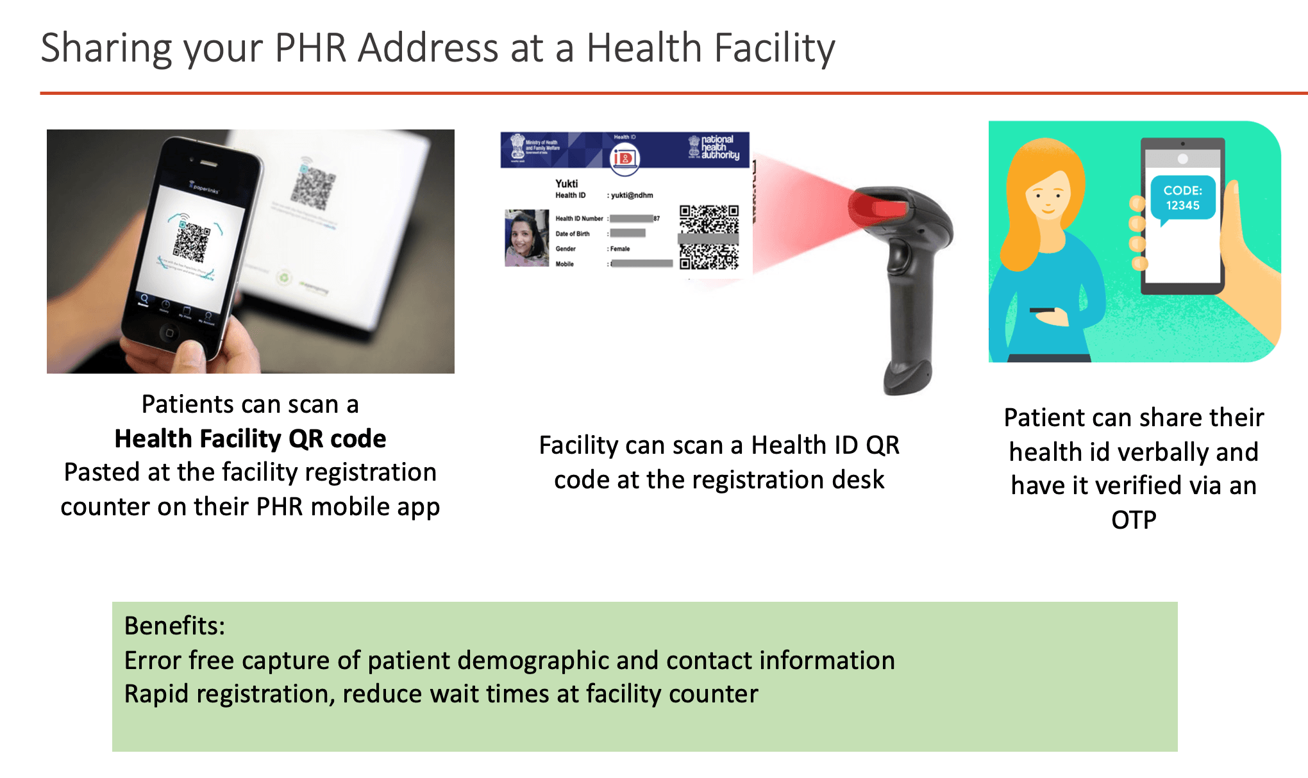
This section covers the methods that must be supported for collecting & verifying the ABHA Address from the user:
- Using ABHA Number
- Using ABHA Address
- Using Mobile
- Using Aadhaar Number
- New vs Returning Patients

Find ABHA number using Mobile number
- New V3 API would provide the list of associated ABHA IDs mapped with a particular mobile number.
- API Input: - Mobile number will be entered in API body which will return list of mapped ABHA numbers.
API Output: - Masked ABHA numbers with personal info i.e. Name and Gender.
- Integrator will select the ABHA ID by providing the respective index from the list of ABHAs.
- Further integrator would have the option to fetch the profile details based on the OTP sent to registered mobile number of the ABHA holder.
- Integrator will get user token once the OTP is verified successfully, and the token can be used to performed further operations.

Enter mobile number to be searched: -
curl --location 'https://abhasbx.abdm.gov.in/abha/api/v3/profile/account/abha/search' \
--header 'REQUEST-ID: 5b4a6001-19dd-4817-978a-cc5fe03059cb' \
--header 'TIMESTAMP: 2024-04-21T07:22:06.682Z' \
--header 'BENEFIT_NAME: benefit-name' \
--header 'Content-Type: application/json' \
--header 'Authorization: Bearer {Auth_Token}' \
--data '{
"scope": ["search-abha"],
"mobile": "RSA Encrypted Mobile Number"
}'
Note: - Benefit Name in Header is only for Government Integrators for others they may remove it from CURL Header.

Request OTP for the specific index list of ABHA ID: -
curl --location 'https://abhasbx.abdm.gov.in/abha/api/v3/profile/login/request/otp' \
--header 'TIMESTAMP: 2024-04-21T07:32:02.178Z' \
--header 'REQUEST-ID: 750b753b-82c1-471a-81dd-1c686efc0425' \
--header 'Content-Type: application/json' \
--header 'Authorization: Bearer {Auth_Token}' \
--data '{
"scope": ["abha-login","search-abha","mobile-verify"],
"loginHint": "index",
"loginId": "RSA encrypted Index Number",
"otpSystem": "abdm",
"txnId":"Transaction ID retrieved from the response of search API"
}'

Profile Login for particular ABHA ID: -
curl --location 'https://abhasbx.abdm.gov.in/abha/api/v3/profile/login/verify' \
--header 'REQUEST-ID: 9de483fb-ffbe-4cfa-b8db-94b857479366' \
--header 'TIMESTAMP: 2024-04-21T07:38:40.999Z' \
--header 'Content-Type: application/json' \
--header 'Authorization: Bearer {Auth_Token}' \
--data '{
"scope": ["abha-login","mobile-verify"],
"authData": {"authMethods": ["otp"],
"otp": {
"txnId": "84003dd3-f02b-45e7-8669-8b6f1ded7a0a",
"otpValue": "RSA Encrypted OTP Value"
}
}
}'

RSA Encryption to encrypt details: -
PublicKey:
MIICIjANBgkqhkiG9w0BAQEFAAOCAg8AMIICCgKCAgEAstWB95C5pHLXiYW59qyO
4Xb+59KYVm9Hywbo77qETZVAyc6VIsxU+UWhd/k/YtjZibCznB+HaXWX9TVTFs9N
wgv7LRGq5uLczpZQDrU7dnGkl/urRA8p0Jv/f8T0MZdFWQgks91uFffeBmJOb58u
68ZRxSYGMPe4hb9XXKDVsgoSJaRNYviH7RgAI2QhTCwLEiMqIaUX3p1SAc178ZlN
8qHXSSGXvhDR1GKM+y2DIyJqlzfik7lD14mDY/I4lcbftib8cv7llkybtjX1Aayf
Zp4XpmIXKWv8nRM488/jOAF81Bi13paKgpjQUUuwq9tb5Qd/DChytYgBTBTJFe7i
rDFCmTIcqPr8+IMB7tXA3YXPp3z605Z6cGoYxezUm2Nz2o6oUmarDUntDhq/PnkN
ergmSeSvS8gD9DHBuJkJWZweG3xOPXiKQAUBr92mdFhJGm6fitO5jsBxgpmulxpG
0oKDy9lAOLWSqK92JMcbMNHn4wRikdI9HSiXrrI7fLhJYTbyU3I4v5ESdEsayHXu
iwO/1C8y56egzKSw44GAtEpbAkTNEEfK5H5R0QnVBIXOvfeF4tzGvmkfOO6nNXU3
o/WAdOyV3xSQ9dqLY5MEL4sJCGY1iJBIAQ452s8v0ynJG5Yq+8hNhsCVnklCzAls
IzQpnSVDUVEzv17grVAw078CAwEAAQ==
Same may be generated by following curl: -
curl --location 'https://healthidsbx.abdm.gov.in/api/v1/auth/cert'
For testing purpose, may use any online tool for encryption, sample given below: -
Online RSA Encryption, Decryption and Key Generator Tool | Devglan
Use Cipher Type as: RSA/ECB/OAEPWithSHA-1AndMGF1Padding

